

|  |
| --- |
| **Microcontroller-Driven Indoor Hydroponic Fodder System** |

**A.K.Ranaweera**

**ITBNM-2110-0046**

**Faculty of Information Technology**

**Horizon Campus**

**Degree of BIT (Hons) in Networking and mobile computing**

**Horizon Campus**

This interim report is submitted in partial fulfilment of the requirement of the Degree of Bachelor of Information Technology (Hons) in Network and Mobile Computing of the Horizon Campu

Table of Contents

**Abstract** 2

**Acknowledgement** 3

**1. CHAPTER 1 – INTRODUCTION** 3

**1.1 Background of the Study** 3

**1.2 Problem Statement** 3

**1.3. Motivation and significant of the project** 4

**1.3.1 Motivation** 4

**1.3.2 Significant** 5

**1.4 Aims and objectives of the project** 5

**1.4.1 Objectives** 5

**1.4.2 Limitations of the Project** 6

**2. CHAPTER 2 – LITERARTURE REVIEW** 8

**Role of Microcontrollers in Hydroponic Systems** 10

**Benefits of Hydroponic Fodder for Livestock** 10

**3. CHAPTER 3 – ANALYSIS** 12

**3.1 System Requirements** 12

**3.1.1 Functional Requirements** 12

**3.1.2. Non-Functional Requirements** 13

**3.2 Existing System Analysis** 14

**3.3 System Specifications** 14

**3.5 Selected Methodology** 15

**Flow chart** 17

**4. CHAPTER 4 – DESIGN** 18

**4.1 Overview** 18

**4.2 System Architecture** 18

**4.3 Block Diagram** 18

**4.4 Circuit Diagram** 19

**4.5 Hardware Requirements** 19

**Conclusion** 20

# **Abstract**

The microcontroller-driven indoor hydroponic fodder system is novel solution using advanced technology to transform fodder production into a highly sustainable and effective means of farming. This technological setup utilizes IoT- based sensors along with automation technologies to create an optimized indoor environment for growth of the nutrient-rich hydroponic fodder as the means to address certain agricultural challenges - limited agricultural land, water scarcity, and fluctuating climate conditions.

This project involves developing an intelligent, self-regulating system that shall monitor and manage environmental factors such as temperature, humidity, and light intensity. The system will utilize various sensors, including but not limited to the DHT11 for temperature and humidity, a turbidity sensor for water quality, and an LDR for light intensity. Real-time data is gathered and used by the system through a microcontroller, such as Arduino, to regulate parameters automatically. Other actuators include LED grow lights and water pumps to ensure ideal growth conditions that improve the speed and quality of fodder growth.

The interface of the system consists of a web application, which is user-friendly and hence enables the farmers to monitor and operate the entire setup remotely. It provides updates on real-time data, visualization with historical data, and sends anomaly alerts to enable evidence-based decisions. That keeps the system's access and usability in order without having broad technical knowledge.

The novelty of the project is that it focuses on resource efficiency. Hydroponic farming uses much less water and space compared to conventional agriculture. The system becomes really advantageous in regions with limited access to arable land or water resources, thus managing to maintain fodder production throughout the year independent of external climatic conditions. Automation and integration of IoT further reduce labor and operational costs.

The proposed system addresses key contemporary agriculture issues related to food security and environmental sustainability, besides offering a scalable model that is adaptable to other crops. This allows him to support small- and medium-scale farmers of livestock by offering an affordable and reliable solution that is not so ecologically damaging.

This work epitomizes how technology-driven innovation can turn around traditional practices into sustainable high-yield systems. Hence, this paper bridges the gap between research and real-world application in setting the benchmark for a future of agricultural practices—the microcontroller-driven indoor hydroponic fodder system.

# **Acknowledgement**

I would like to express my heartfelt thanks to Horizon Campus for giving me the dignity and support needed to carry out this project. The academic environment and infrastructure have been instrumental in my journey.

My unshakable and everlasting thanks should go to my project supervisor, Ms. Naduni Jayathilake for her precious and for tremendous guidance, motivation, support, and smart criticism. The direction and execution of this project have greatly benefited from her expertise and insights. She is, very patient and willing to answer my many questions, and this has greatly enhanced my learning.

My heartiest thanks to my parents, too, for their constant support.

# **1. CHAPTER 1 – INTRODUCTION**

## **1.1 Background of the Study**

Today's pressing concerns facing humanity include climate change, infectious diseases, rising urbanization, and the depletion of natural resource deposits. These factors are causing a radical shift in our worldwide lifestyles. There is a good chance that hydroponic farming will lessen the risks that these problems bring to our food chain. One of the main advantages of hydroponic farming is the use of controlled environment agriculture (CEA) technology to grow crops in nearly ideal circumstances. Indoor hydroponically grown crops can be cultivated anywhere in the world at any time of year, regardless of the weather, the availability of cultivable land, or the quality of the soil. Hydroponic farming holds promise for supplying locally grown, fresh food in regions that experience severe droughts and poor soil quality, such as sub-Saharan Africa, where it is frequently difficult to obtain leafy green vegetables.

Growing plants hydroponically involves utilizing a water-based nutrition solution in place of soil, together with an aggregate substrate or growing media like perlite, vermiculite, or coconut coir. Commercial enterprises, hobbyists, and small farmers all use hydroponic production systems. Hydroponically, practically any crop can be grown, although the most popular ones are watercress, celery, tomatoes, peppers, cucumbers, strawberries, and leaf lettuce. How a crop is sustained in the nutrient solution is an important consideration in system design.

## 

## **1.2 Problem Statement**

promoting a state of good health for all those who choose to live in cities. Our current agricultural system is up to a huge task by 2050,we will need to increase food production by about 70% in order to meet the caloric needs of a global population of 9.8 billion people 68% of whom are projected to live in urban areas.

The amount of resources used by traditional agriculture is a small amount. With most crop production already pushed to its ceiling both genetically and chemically, intensification and the expansion of land used for food production have been seen as the only viable options to meet these growing food demands. Globally, 70% of water usage goes towards agricultural production, largely due to unsustainable irrigation practices. At present, 38% of earth’s non-frozen land is used for growing food. This percentage will continue to rise: by 2050, 593 million hectares of land will need to be transformed into agricultural land to meet the projected calorie needs of the global population if we continue with business as usual. This needed land is equal to roughly double the size of India. This outlook is placing many essential ecosystems at risk of being completely destroyed, especially those that are key to maintaining an already disturbed balance of carbon dioxide in our atmosphere.The bulk of the world's biodiversity lives in rainforests, which are important ecosystems that control the biosphere and are quickly being converted into monocultures for industrial agriculture. Anthropogenic carbon emissions and the worldwide decline in biodiversity are mostly caused by deforestation. The WWF discovered in 2014 that as a result of human exploitation of the planet's resources, 52% of the richness of vertebrate species has already been destroyed. There needs to be an end to the widespread destruction of vital ecosystems, which is the primary cause of the notable decline in biodiversity and disturbance of ecosystem services. Along with many other effects, climate change also poses a threat to agricultural production by bringing wetter climates to areas that are already wet and drier climates to areas that are already dry.

Farming is slowly transforming thanks to hydroponics. Agriculture is expanded by the capacity to grow indoors. Here, we create a miniature grow chamber that is fully mechanized to produce feed indoors in less than a week.The system uses grow lights to mimic sunlight, a temperature-controlled chamber to maintain a cool airflow atmosphere, water and moisture monitoring, and grow lights to assure ideal indoor grow conditions for healthy growth.The device uses an Arduino controller that is interfaced with a keypad to collect user input about characteristics such as indoor optimal temperature and water flow. Subsequently, the system employs temperature, moisture, and water sensors to continuously monitor interior conditions.In order to maintain the ideal temperature and moisture conditions for development, the system monitors temperature and moisture levels using sensors, and uses a pump motor to regulate the water level. Artificial sunlight inside is automatically turned on and off based on user settings.

An Arduino controller effectively oversees the entire procedure to guarantee that it is carried out repeatedly and without fail. In the event that the water tank becomes dry, the system will also sound an alarm. As a result, the Arduino controller-based system guarantees an automated indoor fodder growing system.

## **1.3. Motivation and significant of the project**

## **1.3.1 Motivation**

The indoor hydroponic fodder system, microcontroller-driven, stems from the dire need to alleviate critical agriculture-related challenges such as water scarcity, shrinking arable land, climate change, and increased demand for livestock feed. Traditional methods of fodder production are usually labor-intensive, resource-demanding, and highly dependent on environmental conditions, hence unsustainable for many farmers, especially in areas characterized by limited agricultural resources.

The modern solution to this would be the use of all technological advancement in IoT and automation to bring efficiency in fodder production. It was inspired by the increasing global focus on sustainable agriculture and food security. The project is aimed at making a system that requires less water, less space, and low physical effort to enable small- and medium-scale farmers to produce high-quality fodder throughout the year independent of unfavorable external environmental conditions.

## **1.3.2 Significant**

The importance of this project can be summed up as the great revolution in livestock farming since it will introduce an inexpensive and environmentally friendly way to produce nutrient-rich fodder. Some of the major contributions from this project include:

Resource Efficiency:

The hydroponic system accommodates 70–90% less water compared to a traditional farming methods, thus being extremely apt for regions experiencing water insufficiency. Its compact indoor setup also requires very minimal space, hence an efficient alternative to land-intensive agriculture.

Year-Round Production:

Unlike traditional fodder farming, which relies on seasonal conditions, this system makes it possible to produce throughout the year without interruption, thereby assuring the livestock of a constant feed supply.

Economic Benefits to Farmers:

It will also help in cutting operational costs by automating key processes such as irrigation, lighting, and nutrient distribution. Above all, the ability to grow fodder independent of climatic conditions assures financial stability for farmers.

Technology Adoption in Agriculture: This will encourage farmers to use technology for increased productivity and proper decision-making through integration with IoT sensors, microcontrollers, and user-friendly interfaces. It is in line with the global movement toward "smart farming" and precision agriculture.

The project will, in the final analysis, not only solve today's most important agricultural challenges but also contribute to be a sustainable and technologically driven future in farming. The microcontroller-driven indoor hydroponic fodded system will change the face of livestock farming and promote environmental stewardship by increasing resource efficiency, productivity, & accessibility.

## **1.4 Aims and objectives of the project**

**Aim(s)**

Improvement of hydroponic cultivation through the use of modern technology

## **1.4.1 Objectives**

Following are some general objectives one may keep in mind while embarking on a project in hydroponic farming:

1. Sustainable Agriculture:

Resource- and environment-friendly farming

2. Evergreen Product:

To supply the crops throughout the year with no effects of seasonal changes.

3.Water Conservation:

Conserving water by minimizing the loss and optimizing the irrigation techniques

4. Maximize Space Utilization:

Best land-use or space would be utilized by vertical farming and small hydroponic systems.

5.Enhance Crop Quality:

Raise superior crops, enhanced in flavor, nutrition, and appearance.

6.Crop Yield increase:

Surpass conventional soil-based farming in output per unit area.

7. Control:

Through control over the growth area, lessen the chances of infection from soil-borne diseases and pests.

8. Educational Outreach:

The company shall always undertake to offer educational programs to the general public, schools, and any interested party seeking knowledge about modern farming methods and sustainable agriculture.

9. Job Creation:

Design and maintain hydroponic farming systems in ways that create jobs within the community.

10. Food Innovation:

For food innovation, experimentation should be encouraged on diversified crops, some of which are less traditional within mainstream agriculture.

## **1.4.2 Limitations of the Project**

•Limited Scalability:

The system may not scale for larger enterprises without considerable modification and changes since it was intended for small-scale application. Similarly, though an Arduino platform is versatile, there are memory and computational capacity limits that may restrain the system's complexity and scale.

•Sensor Accuracy and Reliability:

Low-cost sensors utilized in Arduino applications are inconsistent in their reliability and accuracy. The inconsistency of the sensors could mean that the system may not maintain optimal growing conditions, which may have effects on plant health and growth.

• Maintenance and Calibration

Sensors and actuators should be serviced and calibrated periodically to ensure appropriate operation of the systems. Poor maintenance leads to less than perfect growing conditions due to friction of the mechanical parts and sensor drifting.

Initial Setup Costs

Initially, the investment in the setup involving buying of sensors, microcontrollers, LED grow lights, and other peripherals involved is very high for a small-scale farmer. This can be one of the major deterrents to the adoption, especially in low-income farming communities.

Dependency on Electricity

Most of the operations in the system require electricity for the microcontroller, sensors, lighting, and water pumps. Since there is power instability in most regions, efficiency may be lowered in the workability of the system. Although backup systems, like solar panels, could be considered, they add to upfront costs.

Knowledge Gap in Adoption

Farmers usually have no experience with IoT-based systems and thus may have various problems with its adoption. Training should be provided, along with user-friendly interfaces that would bridge the gap, but this requirement takes time and additional resources.

Water Quality Dependency

This system is heavily relying on the quality of water used. The use of poor water quality, carrying excessive minerals or contaminants, may interfere with plant growth and clog irrigation systems. Advanced water filtration may be needed and perhaps will be more expensive.

# **2. CHAPTER 2 – LITERARTURE REVIEW**

The need for efficient and sustainable agricultural practices has recently brought hydroponics into the limelight as one of the potential means of food production. As agricultural practices face increasing pressure, innovative approaches, such as hydroponics, have been considered—a manifestation of the soilless cultivation of crops, particularly in an urban set-up and resource-constraint system. Through this literature review, the present study aims to explore the microcontroller-driven indoor hydroponic fodder system in terms of its design, implementation, and benefits. Hydroponics is a method for growing plants without soil, and its resource use efficiency to produce high-quality fodder in a controlled environment has therefore gained relevance.

1. Automation system based on IoT

Muhammad E. H. Chowdhury et al (2020) explored the design, construction and testing of an automated IoT-based indoor vertical hydroponic farming test bed in Qatar. The system uses IoT technology to manage and monitor hydroponic operations, making it suitable for arid environments.

1. Mobile application integration

Kunyanuth Kularbphettong and colleagues (2019) developed an automated hydroponic system based on a mobile app in Thailand. The system is designed to increase user convenience and productivity through remote control and monitoring of hydroponic systems, including automatic nutrient replenishment and environmental adjustments.

1. Nutrient and moisture management

Shreya Tambay et al. (2019) proposed an automated hydroponic system based on the Internet of Things, focusing on the precise management of water and nutrient solutions. The system automatically adjusts nutrient delivery and monitors environmental conditions to optimize plant growth The development of small-scale indoor hydroponic feed production systems covers various studies highlighting the importance and effectiveness of hydroponic systems in feed production, especially in areas with limited land and water resources.

**Introduction**

The need for efficient and sustainable agricultural practices has recently brought hydroponics into the limelight as one of the potential means of food production. As agricultural practices face increasing pressure, innovative approaches, such as hydroponics, have been considered—a manifestation of the soilless cultivation of crops, particularly in an urban set-up and resourceconstraint system. Through this literature review, the present study aims to explore the microcontroller-driven indoor hydroponic fodder system in terms of its design, implementation, and benefits. Hydroponics is a method for growing plants without soil, and its resource use efficiency to produce high-quality fodder in a controlled environment has therefore gained relevance. In this review, an attempt has been made to synthesize findings from various studies to arrive at an in-depth understanding of the topic and to establish a foundation for future research in this area. The review shall focus on the technological evolution of hydroponic systems, the input of microcontrollers, and livestock feeding with agricultural sustainability. It argues for the benefits that accrue in the use of hydroponic systems and the challenges experienced in their actualization. With regard to such considerations, the review establishes a basis for understanding the contribution of microcontrollers toward the optimization of indoor hydroponic systems in fodder production.

Another objective would be to review the progress on, as well as applications of, microcontrollerdriven indoor hydroponic fodder systems, specifically considering design factors that address functionality and agricultural productivity. The review is drawn from a variety of recent studies that have emphasized some themes, such as the technological frameworks applied. Through the synthesis of findings from various sources, this review provides insight into the current understanding of microcontroller-driven indoor hydroponic systems and future directions.

**Technological Advancements in Hydroponic Systems**

In this regard, recent research in hydroponic systems is focused on the integration of microcontrollers and IoT. Abu Sneineh and Shabaneh [1][7] present an example of a smart hydroponics monitoring system using an ESP32 microcontroller that automates the collection of environmental parameters, including pH, temperature, and nutrient levels. This system improves efficiency in water and nutrient supply and allows access from anywhere through applications like Blynk. The authors have observed that real-time data collection enables the optimization of plants' growth conditions and avoids the wastage of resources.

Ghorbel and Koşum [5] [18]describe the advantages of hydroponic fodder production, specifying that it can be performed on completely closed surfaces, thereby ensuring maximum production with the smallest possible area of land consumption. In their view, hydroponic systems can produce high-quality fodder all year round without being subject to the constraints of conventional agricultural production.

The microcontrollers are introduced to the hydroponic system to automate activities related to nutrient supply and environmental factors. Thus, Susilawati et al. have discussed the design and development of an Arduino microcontroller-based automatic hydroponic plant watering system that enhances the efficiency of the management of its nutrients by its sensors, which measure water and nutrient levels. It not only automates the process of watering but also provides real-time data related to nutrient concentrations to ensure that plants are subject to optimum conditions for growth.

On the other hand, Bhat et al. have suggested a mini set-up of indoor hydroponic fodder production with LED lighting and automated irrigation to get maximum yield with a minimum consumption of water [10][19]. In this set-up, the amalgamation of microcontroller technology with controlled lighting helps in the production of fodder throughout the year independently of seasonal changes in natural light.

# **Role of Microcontrollers in Hydroponic Systems**

Microcontrollers set the core of automated hydroponic systems in real-time monitoring and environment control. Deshan et al. (2024) present an integrated device called "HypoSense" for monitoring temperature, humidity, pH, and light intensity. The adoption of Arduino-based microcontrollers in this device simply proves that affordable technology has all it takes to realize precision agriculture through the provision of accurate data to growers and reducing manual labor. The authors emphasize that these systems can increase efficiency for hydroponics farming considerably for smaller growers who lack the resources to undertake an expensive commercial setup [14].

Microcontrollers form a very vital aspect of automating and optimizing hydroponic systems. In another contribution to evaporative cool hydroponic chambers, Singh et al. [3][4] make a review using microcontroller technology for the creation of an enabling environment for fodder production. Some authors report improved temperature regulation and humidity control; two very critical factors for better growing conditions of hydroponic crops. This integration of technology increases crop yield while decreasing labor costs for monitoring and managing the same by hand.

Reddy and Harani [2] add that even microcontroller-driven systems are economically viable since they occupy less space and require fewer resources compared to conventional farming. In the process, monitoring environmental conditions in real time offers quite an advantage in areas experiencing undesirable climatic variability and water scarcity.

# **Benefits of Hydroponic Fodder for Livestock**

Hydroponic fodder has long been documented to be nutritionally beneficial. Thalkar strongly emphasizes that the production of hydroponic fodder reduces water usage by as low as 4.78 liters per kilogram of the produced fodder in comparison to conventional methods, which often require much more. This can be immensely useful in saving water in water-scarce areas. Ghorbel and Koşum [5] further insist that hydroponically grown fodder is rich in protein, vitamins, and minerals, hence good for feeding livestock. With the short production cycle of hydroponic fodder, the freshness of the feed in the stock is always assured, more so in areas with a limited supply of traditional fodder. The nutrient profiles of hydroponically grown fodder are also superior on many counts.

According to a comparative study by Barwant et al., hydroponic fodder not only increases nutritional value in feed but also improves livestock health and productivity, thus consequently raising milk yield and weight gain in animals [8]. It allows for close control over nutrient delivery, thus allowing tailored feeding regimens for improving the performance of livestock.

Hydroponic systems have many advantages from an environmental point of view, mainly because of resource conservation. Newell et al. [11][17] considered the greenhouse gas emissions related to hydroponic fodder production. It was determined that such a process reduces these emissions compared to conventional fodder cultivation. According to this study, hydroponically cultivated fodder uses fewer water resources and reduces the use of land to a minimum, which is very beneficial in terms of fighting climate change. The authors believe that hydroponics holds an opportunity for a more sustainable agricultural model, particularly in areas where the environment is degraded.

According to Singh et al. [3][16], it was observed that feeding hydroponically produced fodder to livestock improved digestibility and nutrient absorption. Therefore, improving milk production and enhancing general animal health would depend on it. They argue that incorporating hydroponic systems into livestock feeding regimes will greatly enhance both food security and sustainable agricultural practices.

**Challenges and Limitations**

This is not to say that there are no challenges in adopting microcontroller-driven hydroponic systems: considerable challenges will include the set-up cost, the technical know-how needed to run them, and so forth. Thalkar reveals that high returns come with an attachment of huge investment in the technology and infrastructure in advanced hydroponics [6].

Reddy and Harani [2][9] assert that education concerning hydroponic systems should be continuous, and support to the farmers provided on an ongoing basis to effect change. The findings also suggest that optimization studies should further be performed for the development of nutrient solutions and growing conditions for the requirements of other crops/livestock.

However, such reliance on technology introduces the scope for failures or malfunctioning of a system, which can result in extreme risks to crop yields. Thus to maintain and troubleshoot these systems effectively, according to Mardiansyah et al., the users need training, otherwise the potential of hydroponic systems is wasted on underperformance.

**Nutritional Advantages of Hydroponic Fodder**

Another critical factor in adopting hydroponically grown fodder is its nutritional value. On the same note, Malhi et al. [12] emphasize that hydroponic fodder is rich in essential nutrients and, therefore, a better feed for the animal inventory. Value Addition to Livestock Feed: This study has shown one can increase digestibility and milk production by 8-13% just by introducing it into animal feeding. In areas where traditional sources of fodder are limited or low in quality, this nutritional benefit is of great importance.

The nutritional makeup of hydroponic fodder could be different depending on light intensities, and nutrient solutions, among others. Bedeke et al. (2024) examine the economic incentives to adopt hydroponic fodder production among pastoralist households in Ethiopia. There is a high improvement in household income through the reliable supply of high-quality feed for livestock production realized when hydroponic fodder is used in the livestock enterprise. These results show the potential of microcontroller-driven systems to enhance agricultural efficiency and contribute to economic stability in farming communities [13].

**Automation and IoT in Hydroponic Farming**

Their integration with the Internet of Things allows hydroponic systems to help in better automation and data-driven decision-making. On this topic, Suresh et al. (2024) describe an IoTenabled hydroponic system fitted with sensors to monitor some critical parameters, like pH, electrical conductivity, and water level, to ensure growing conditions are at their best while preventing any waste of resources. The authors say that IoT integration provides operational efficiency and the facility for remote management of systems to farmers, thereby improving productivity and sustainability.[15]

**Future Directions**

Although the future of microcontroller-driven indoor hydroponic systems may seem encouraging, research is underway to enhance the resilience and efficiency of the system. Investigations are going on, especially in innovations such as IoT integration for remote monitoring and control, in order to make the functioning of the system smoother. Apart from that, it may also have reduced operational costs and increased sustainability by using alternative energy sources, such as solar power, within research. The focus of future research should thus be on the development of costeffective, user-friendly systems that farmers can easily adopt in various agricultural scenarios.

**Conclusion**

In conclusion, microcontroller-driven indoor hydroponic fodder systems hold immense promise for advancing agricultural sustainability and food security. The integration of automation and IoT technologies enhances resource management, crop yields, and the nutritional quality of livestock feed, offering a viable solution for fodder production in resource-constrained environments. Despite these benefits, challenges such as microbial risks, high initial investment costs, and the need for technical expertise must be addressed to ensure the widespread adoption of these systems. Future research should focus on optimizing system designs, improving disease management, enhancing user training, and integrating sustainable energy sources. By overcoming these obstacles, the agricultural sector can fully harness the potential of hydroponic systems to meet the increasing demand for sustainable and efficient livestock feed production.

# **3. CHAPTER 3 – ANALYSIS**

## **3.1 System Requirements**

In this section, we analyze the specific needs and requirements that must be met for the system to function effectively. These are divided into functional and non-functional requirements:

## **3.1.1 Functional Requirements**

Monitoring of Sensor Data:

Be continuously informed about environmental parameters like temperature, humidity, TDS level, and moisture level.

Automatic Control:

Automatically running water flow via pumps and solenoid valves based on sensor readings.

LED grow lights are controlled to simulate natural sunlight by switching them on/off to maintain a certain light intensity as per predefined requirements.

Nutrient Delivery System:

Provide the appropriate quantity of nutrient solution to the hydroponic trays at the right time

Real-Time Feedback:

Display the system parameters such as temperature, humidity, and TDS level and moisture level on the LCD screen.

IoT Connectivity:

Provide remote monitoring and control of the system through any mobile or web-based application.

Energy Efficiency:

The functioning of various components of the system efficiently decreases energy consumption.

## **3.1.2. Non-Functional Requirements**

Reliability:

The system will operate for long periods without interruption, with minimal system downtime.

Scalability:

Assuming this would be extended to more trays or sensors, the system design should support such scaling.

Performance:

Sensor data shall be processed, and reaction time in case of changes shall be less than 1 second.

Environmental conditions should be regularly maintained to achieve optimal fodder growth.

Usability:

Use is made easy via a simple-to-use, intuitive interface for user-system interaction.

The system must be easy to install and set up.

Maintainability:

Design components to be modular and easily replaceable or upgradable when needed. Provide clear error messages and self-diagnosis capabilities whenever failures may occur with the system.

Security:

Perform encryption on IoT communication to avoid unauthorized access. Limit physical access to the hardware components themselves.

## **3.2 Existing System Analysis**

**IoT integration challenges:**

Most of the existing systems have not employed IoT for remote monitoring.

Systems without IoT features need on-site management all the time.

**Need for Improvement:**

Presently, no existing system has been able to provide an economical, automated, and scalable solution that is required for continuous resource-efficient production of fodder.

**Automated Hydroponic Systems (Exiting)**

Advanced hydroponic systems employ automation for the regulation of the amount of water, nutrients, and other environmental conditions. These could include:

Automated Pumps and Nutrient Delivery: Nutrients are automatically added to water, but monitoring and adjustments in TDS are still left to manual intervention.

Lighting Control: There is automation in lighting, but the system does not necessarily respond to plant growth stages.

Challenges

Limited Remote Access: Monitoring and controlling the system often require physical presence or manual logging of data.

## **3.3 System Specifications**

**Hardware Specifications**

Microcontroller:

Model: ESP 8266 or Arduino Uno

Function: This will serve as the central control unit that receives data from sensors and issues commands to various actuators. Its purpose will be to automate irrigation, lighting, and delivery of nutrients.

Connectivity: With a built-in Wi-Fi module for IoT functionality, this should be able to be monitored through an application or web interface .

Temperature Sensor (DHT11 or DS18B20): Provides ambient temperature.

TDS (Total Dissolved Solids) Sensor: Provides the nutrient concentration in water.

Moisture Sensor (Capacitive or Resistive): Detects moisture content in the growing medium-soil or hydroponic trays.

**Actuators:**

Water Pump: For nutrient solution/water delivery

LED Grow Lights: Full-spectrum LED lights to support photosynthesis.

Cooling Fan or Heater (Optional): To control the temperature.

**Software Specifications**

Libraries: DHT11, TDS, and moisture sensors. Since the ESP8266 will be used for remote monitoring, its IoT library-usually Blynk or ThingSpeak-will be employed.

Real-Time Control and Automation:

The system has predefined threshold levels in terms of temperature, humidity, moisture, and TDS levels. The system automatically switches on the pump, lights, or fans if its parameters are out of the range from the ideal ones.

• Arduino IDE ( C++, Adriano.)

• Website development platform - Visual Studio, for example, C++, HTML

• Cloud Service – Firebase

## **3.5 Selected Methodology**

**System Design:**

The design includes connecting the necessary elements to an Arduino microcontroller in order to automate the growth process. It will integrate sensors, actuators, and IoT modules to monitor and control key parameters such as TDS levels, temperature sensor DHT11, and moisture levels while enabling manual control when needed.

Manual Control:

Manual Switch for Water Pump: This allows the operator to start and stop water supply manually. Manual Switch for LED Grow Lights: Allows the operator to turn lights on/off without system automation.

**Programming:**

Here is the simplified Arduino code for the microcontroller-driven indoor hydroponic fodder system. The program below incorporates sensor readings, actuator control, and basic decision logic for the system. The system will monitor temperature, TDS level, and moisture level while activating actuators that include a water pump, LED lighting, and a cooling fan. Available options in the program are also given for manual control

**Testing and Calibration**

Each sensor, whether temperature, TDS, or moisture, has to be calibrated with known reference values for accurate reading. The TDS sensor is normally calibrated using standard solutions, whereas the moisture sensor is subjected to different soil conditions to check its response. Different actuators such as pumps and fans are also checked upon to see if their activation depends upon the threshold level set by sensors. The system-wide testing will involve the setup running under controlled conditions to validate the automated responses and manual overrides. Regular calibration ensures long-term accuracy and efficient performance of the system.

**Integration and Optimization:**

Hardware Integration:

Sensors (temperature, TDS, and moisture) and actuators-pump, fan, grow lights-must be connected to the microcontroller. The sensors must provide seamless data flow, and the actuators will take commands from the microcontroller.

Software Integration:

The integrated program has to process sensor data, automate the actuators, and interface with the IoT platform for remote monitoring

IoT and User Interface:

Integrate IoT modules that log data in real time using a user-friendly web interface.

Testing for Efficiency:

Perform the end-to-end tests to make sure everything works together, with optimal response times and overall system reliability.

## **Flow chart**

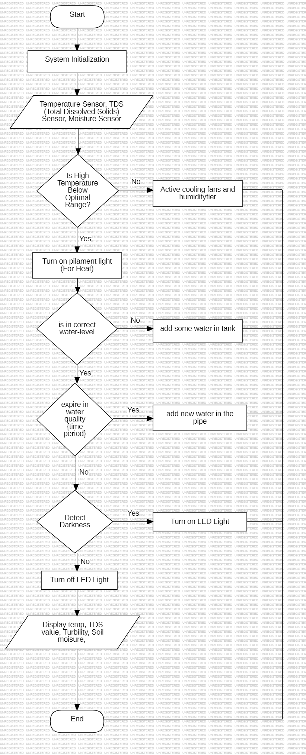

# **4. CHAPTER 4 – DESIGN**

## **4.1** **Overview**

The automation of the Microcontroller-Driven Indoor Hydroponic Fodder System develops further to optimize hydroponically produced fodder for livestock. Equipped with sensors, actuators, and IoT technologies that keep a close check on critical parameters such as temperature, TDS levels, and moisture content, the system assures accuracy in environmental modifications, water, and nutrient optimization, real-time data visualization, and user-friendly interfacing by incorporating a microcontroller as its central unit. It is supported by both automated and manual control, hence flexible and reliable. Its major objectives include increasing productivity while reducing resource consumption, hence offering a sustainable and scalable solution for modern agriculture.

## **4.2 System Architecture**

Fundamentally, there is the potential to drive an indoor hydroponic fodder system by using sensors, actuators, a microcontroller, and IoT connectivity within a modular architecture. The microcontroller-for example, the ESP8266—may be the central unit performing some computation based on real-time data from sensors for temperature, moisture, and TDS. In response to sensor inputs,, actuators-water pumps, grow lights, and cooling fans-maintain optimum conditions for growth:. The system integrates a Wi-Fi module for remote monitoring via web interface. This design enables scalability, efficiency, and seamless system operation

## **4.3 Block Diagram**

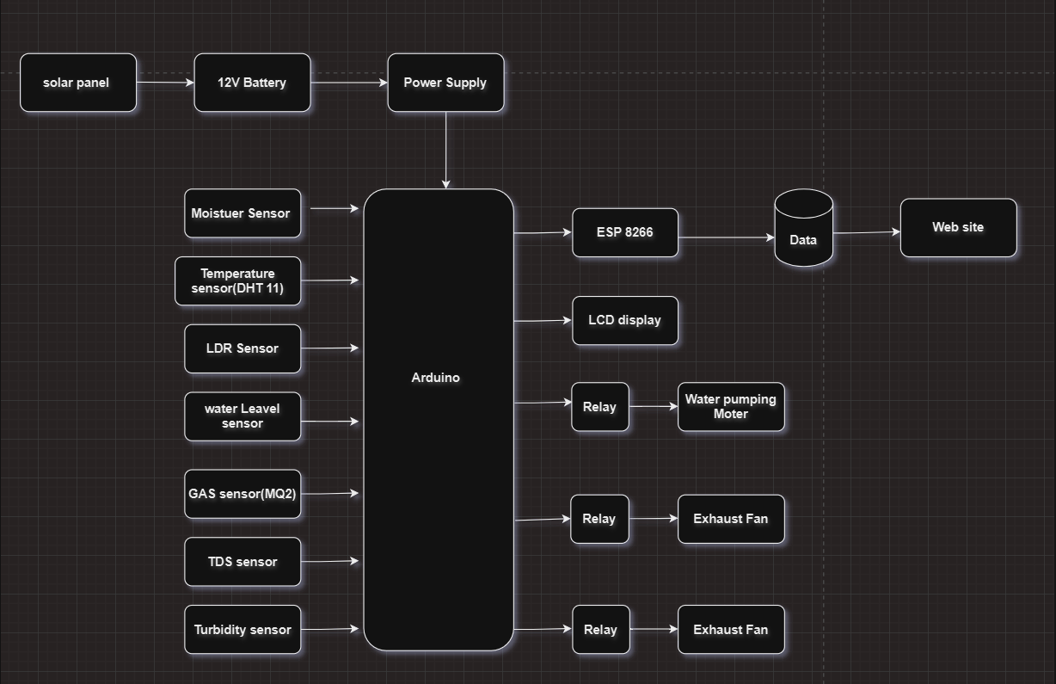

## **4.4 Circuit Diagram**

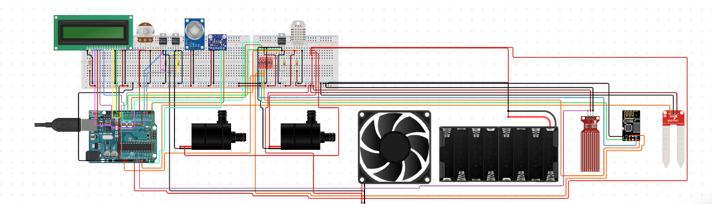

## **4.5 Hardware Requirements**

This indoor hydroponic fodder device will be controlled with the help of the microcontroller, accompanied by key hardware components that include the microcontroller, containing data processing and control. The examples include ESP8266 or Arduino Uno, sensors that monitor operating environment variables: temperature sensor DHT11, moisture sensor, TDS sensor, and actuators such as the water pump, LED grow lights, and a cooling fan to maintain operating growing environment parameters. The system includes a 16×2 LCD display for local, real-time data presentation, an ESP 8266 Wi-Fi module for connecting to the Internet of Things for remote monitoring, a 12V DC adapter, or a solar panel for its sustainable powering. Hydroponic trays and a water reservoir complete the system.

**Hardware:**

* **Arduino board** –( Acts as the central microcontroller to receive inputs from sensors, process data, and control outputs like displays, pumps, or LEDs.)
* **Moisture sensor** –( Measures the moisture level in the soil. Commonly used in gardening or agriculture to monitor soil hydration.)
* **DHT 11 sensor** –( Measures temperature and humidity. Useful for environmental monitoring or controlling climate in a controlled space like a greenhouse.)
* **LCD Display** - (Shows information such as sensor readings, status messages, or alerts to the user in a readable format.)
* **Water level sensor** –( A water level sensor is a device used to detect and measure the level of water or other liquids within a container, tank, or system. It plays a critical role in monitoring and controlling water levels, particularly in automated systems.)
* **TDS sensor** –( Measures the Total Dissolved Solids (TDS) in water, indicating its purity or contamination level.)
* **LDR sensor** –( Measures light intensity. Can be used for light level detection or to control lighting based on ambient light conditions.)
* **ESP8266** –( A Wi-Fi module that enables your project to connect to a wireless network for internet access or remote control.)
* **Turbidity sensor** –( Measures the cloudiness or haziness of a liquid. Often used to assess water quality.)
* **Water pump** – (Used to move or circulate water, often for irrigation or hydroponic systems.)
* **Exhaust Fan** –( Provides ventilation to remove heat or fumes, improving air quality in an enclosed space.)
* **LED** –( Light Emitting Diode, used for visual indicators or status lights.)
* **Battery Pack** –( Provides power to the entire system when not connected to an external power source.)
* **Breadboard and Connecting Wires** –( Used for prototyping and connecting electronic

components without soldering.)

* **Sola Panel (** Used for store the power and saving power**)**

**Software:**

* Arduino IDE (Designed for C++ Adriano.)
* Web site Development Platform (e.g. Visual studio, (c++,html) )
* Cloud Service (e.g.,firebase )

## **Conclusion**

A microcontroller-based indoor hydroponic fodder system is a modern and upgraded solution to the problems thrown up through conventional methods of fodder production. This was all put together to give a brilliant resource-saving means of growing superior quality fodder throughout the year. With attached sensors to detect temperature, moisture, and TDS levels, the system enables accurate modification to provide all optimum growing conditions. Actuators have allowed for water pumps, LED grow lights, and cooling fans that ensure consistent automated control to minimize human intervention, hence reducing labor costs.

Some of the benefits accruable from this will be less water usage, optimization of nutrient delivery, use of minimum dependence on arable land. The farmer will have more access and usability by way of IoT-enabled interface for remote monitoring and control. While it addresses some critical problems in agriculture, this system contributes to the attainment of sustainable development goals set forth in the world because it encourages efficient resource management as well as eco-friendly best practices. It is modular, hence scalable, and can thus go further in developing renewables with advanced data analytics.

Therefore, the system will bridge the gap between technology and agriculture with a new methodology of betterment in productivity and its sustainability in the production of fodder.

**References**

[1] A. Abu Sneineh and A. A. Shabaneh, "Design of a smart hydroponics monitoring system using an ESP32 microcontroller and the Internet of Things," MethodsX, vol. 11, 2023.

[2] P. Bagavan Reddy and M. Harani, "Hydroponics: A sustainable way of green fodder production," Indian Farming, vol. 73, no. 2, pp. 2-5, Feb. 2023.

[3] S. K. Singh et al., "Development and performance evaluation of evaporative cool hydroponic fodder production chamber," Range Management and Agroforestry, vol. 43, no. 1, pp. 132-138, Aug. 2022.

[4] A. Adelowokan et al., "Evaluating the performance of small-scale indoor vertical hydroponics systems for lettuce production," Poster, June 2023.

[5] R. Ghorbel and N. Koşum, "Hydroponic Fodder Production: An Alternative Solution for Feed Scarcity," Proceedings of the 6th International Students Science Congress, Sept. 2022.

[6] M. G. Thalkar, "Hydroponics technology for fodder production," Agriculture and Food Magazine, vol. 1, no. 11, pp. 84-89, Nov. 2019.